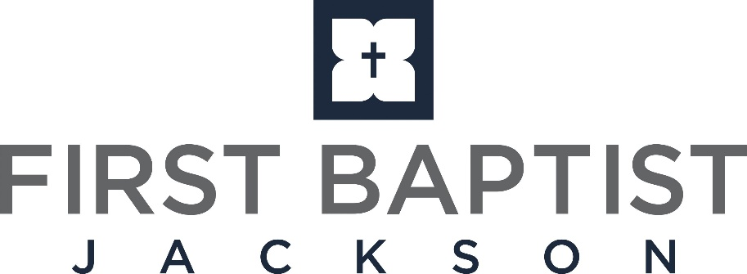

Committee on Committees Nomination Form
September 26, 2021
2021 Committee on Committees
Greg Fiser, Chairman Chad Cockrell Reta Haire Doug Rule Todd Adkins Kelsey Dennis Fred Rushton Buddy Huff Ann Southerland
I Peter 4:10 NKJV says “As each one has received a gift, minister it to one another, as good stewards of the manifold grace of God.”

Each year our church has the opportunity to nominate and elect church members who possess these spiritual gifts and talents to serve on the seven church Standing Committees and the Leadership Council within our church. With so much excitement and opportunity ahead for First Baptist Jackson, it is a great time to select men and women from our congregation to work alongside Pastor Chip and our wonderful church staff to guide our church and do Kingdom work.

The Committee on Committees is charged each year with recommending to the church, the members to serve in these elected positions. This year’s Committee on Committees is ready to begin the process, and we humbly ask that you assist us. Here is how each church member can assist:
- Prayerfully consider and nominate men and women for the 16 vacant, church-elected committee positions, by placing their name(s) in the light blue “Church-Elected” boxes on this form.
- Remember that nominees for all committees must have been a church member for the last three years.
- If you wish, please feel free to write a comment as to why you feel led to nominate this person and include your name. This is always helpful to the members of the Committee on Committees as they evaluate nominations.
- Find nomination forms at the church information booths on the 2nd and 3rd floors and also on the church’s website (www.FirstBaptistJackson.org/committee-nomination).
- Please submit nominations by the deadline of 5:00 P.M., on Monday, October 25, 2021.
- Be prepared to vote on the committee recommendations in November. The date and time of this business meeting will be announced at a later date.

Thank you for submitting nominations to the Committee on Committees. We are very grateful for your help in this process, and we would appreciate your prayers as we seek God’s will to select men and women to serve and lead our church.
If you have any questions, please feel free to contact any member of the Committee on Committees.
Sincerely,
Greg Fiser
Chairman – 2021 Committee on Committees

LEADERSHIP COUNCIL (9) - To be a helpmate of the Senior Pastor in carrying out the Senior Pastor’s leadership role by providing support, accountability, and additional insight.
Chip Stevens, Senior Pastor and Chairman
2022 Bob Filgo, Deacon Chairman Brad Antici, Finance Chairman
Jim Merritt, Jr, Personnel Chairman Lenora Bigler
2023 Mark Rich, Deacon Chairman Bill Boteler
2024 Todd Adkins, Deacon Chairman ___________________________, Church-Elected
Nomination Submitted By: _______________________
Comments: __________________________________________________________________________________________________
____________________________________________________________________________________________________________
COMMITTEE ON COMMITTEES (9) - Recommends to the church the members to serve in Leadership Council positions and the church-elected positions on the church Standing Committees.
2022 Fred Rushton, Chairman Buddy Huff Ann Southerland
2023 Todd Adkins, Chairman Chad Cockrell Reta Haire
2024 Steve Dukes, Chairman Tom Walker, Sr. Pastor Filled Robin Wise,WEM/WMU
Comments: __________________________________________________________________________________________________
____________________________________________________________________________________________________________
FINANCE COMMITTEE (9) - Responsible for the proper expenditures of all funds given to First Baptist Jackson.
2022 Brad Antici, Chairman Justin Stroud David Hancock
2023 John Scarbrough, Chairman Jackie Gunn Paul Calhoun
2024 Cody Bailey, Chairman ___________, Church-Elected ____________, Church-Elected
Nomination(s) Submitted By: _______________________
Comments: __________________________________________________________________________________________________
____________________________________________________________________________________________________________
PERSONNEL COMMITTEE (9) - Responsible for overseeing all personnel and human resources matters of the church.
2022 Jim Merritt, Jr., Chairman Lee Ann Thigpen Mark Williams
2023 Buddy Huff, Chairman Paul Adcock Patsy Parkin
2024 Mark McConnell, Chairman ___________, Church-Elected ____________, Church-Elected
Nomination(s) Submitted By: _______________________
Comments: __________________________________________________________________________________________________
____________________________________________________________________________________________________________

BUILDING & MAINTENANCE COMMITTEE (9) - To oversee the operation and maintenance needs of the physical plant of our buildings and facilities. The Committee also addresses furnishings, furniture, and décor needs throughout our buildings, and serves as a clearing house for all such recommendations.
2022 Frank Stebbins, III, Chairman Jerold Sit Royal Catchings
2023 Johnny Newell, Chairman Sandra Gobbel Rodney DePriest
2024 Sonny Kullman, Chairman ________, Church-Elected ____________, Church-Elected
Nomination(s) Submitted By: _______________________
Comments: _________________________________________________________________________________________________
___________________________________________________________________________________________________________
EVANGELISM COMMITTEE (9) - To plan, coordinate, and oversee the training, equipping and deployment of our church members seeking to share the gospel in our community (Jerusalem and Judea), country (Samaria), and world (ends of the earth).
2022 Richard Corkern, Chairman Clara Torns Peg Guthrie
2023 Brad Moreman, Chairman Jeff Zachary __________, Church-Elected
2024 John Lewis, Chairman __________, Church-Elected __________, Church-Elected
Nomination(s) Submitted By: _______________________
Comments: __________________________________________________________________________________________________
____________________________________________________________________________________________________________
INVESTMENT COMMITTEE (9) - To manage funds of First Baptist Jackson in accordance with the investment policy of the church and any specific provisions as stated in documents creating any endowment of the church.
2022 Bob Turner, Chairman Robert Halford Blake Johnson
2023 Travis Woods, Chairman Ashley Mosley Rebecca Greer Barrett
2024 Blake Headley, Chairman __________, Church-Elected ____________, Church-Elected
Nomination(s) Submitted By: _______________________
Comments: __________________________________________________________________________________________________
____________________________________________________________________________________________________________
DEACON NOMINATING COMMITTEE (10) - To evaluate and recommend men to be selected for service as Active, Reserve and Life Deacons.
2022 Richard Rebich, Chairman Bae Waller Bill Boteler
Mark Rich, 2023 Deacon Chairman
2023 Karan Payne Jeff Zachary Cody Bailey
2024 Brian Fortenberry, Chairman Michael Ford, Sr. Pastor Filled Jo Anne Massey, WEM/WMU

WEM/WMU EXECUTIVE COMMITTEE (9) - Nominates female church members to serve on Committee on Committees and Deacon Nominating Committee.
2022 Mitzi Norris Linda Scafidel Elizabeth Rich
2023 Rhonda Armstrong Devin Mosley Millie Quarterman
2024 Jessica Holmes Nancey Byrd Crissie Walker

INTERCESSORY PRAYER COMMITTEE (9) - To promote and encourage a consistent prayer ministry for our church. This ministry provides the opportunities for our church family to pray for missionaries around the world, daily needs of our congregation, and for the needs listed from our Sunday School classes and worship.
2022 Andy Talley, III, Chairman Mary Lee Steele Dottie Hudson
2023 Danny White, Chairman Sarah Elliott Patricia Switzer
2024 David Nichols, Chairman _______, Church-Elected _____, Church-Elected
Nomination(s) Submitted By: _______________________
Comments: __________________________________________________________________________________________________
____________________________________________________________________________________________________________
MISSIONS COMMITTEE (9) - To oversee the mission ministries of the church. They work with the WEM/WMU and the Evangelism Committee to train, equip, and deploy mission ministries to our community (Jerusalem and Judea), country (Samaria), and the world (ends of the earth) through direct involvement, giving, and prayer.
2022 Doug Parkin, Chairman Josh Dennis Gee Wei Lee
2023 Doug Gunn, Chairman Amy Perkins Matt Jones
2024 Matt Jones, Chairman ___________, Church-Elected ____________, Church-Elected
Nomination(s) Submitted By: _______________________
Comments: __________________________________________________________________________________________________
___________________________________________________________________________________________________________
Church-Elected

WEM/WMU
Sr Pastor Filled
Deacon Chairman Filled

